Visa Classic Debit

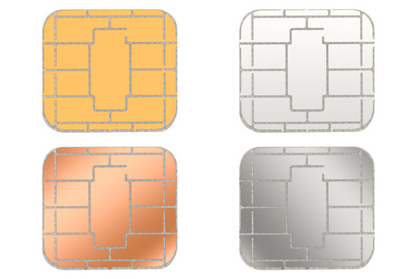

1234 5678 1234 5678



12/25

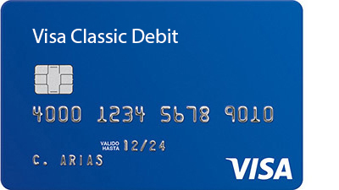

DIVYA